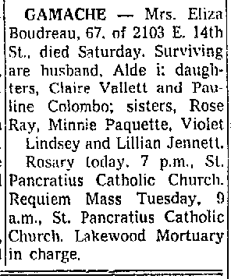

page 12 of: (Long Beach CA)Press Telegram September 12, 1960

