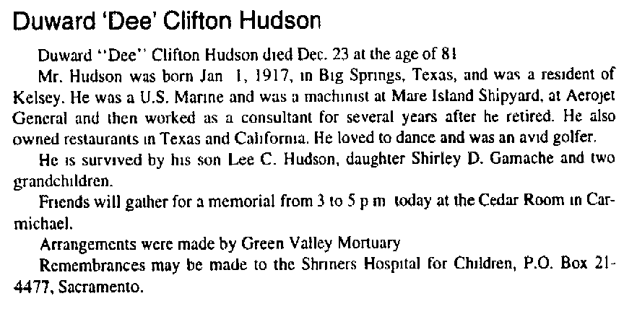

page 4 of: Placerville Mountain Democrat December 30, 1998

