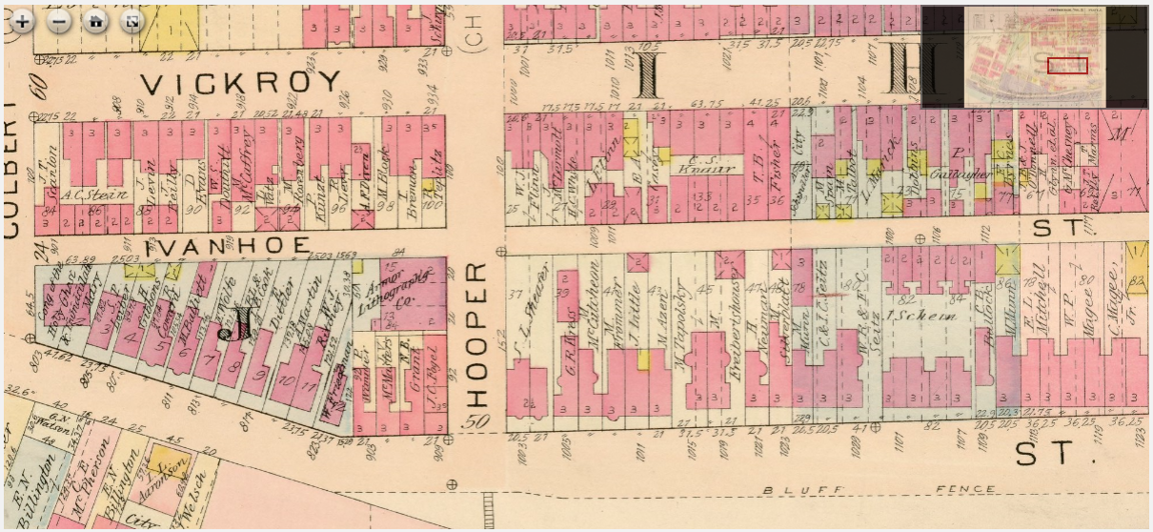
Max Azen 1013 Bluff Street

