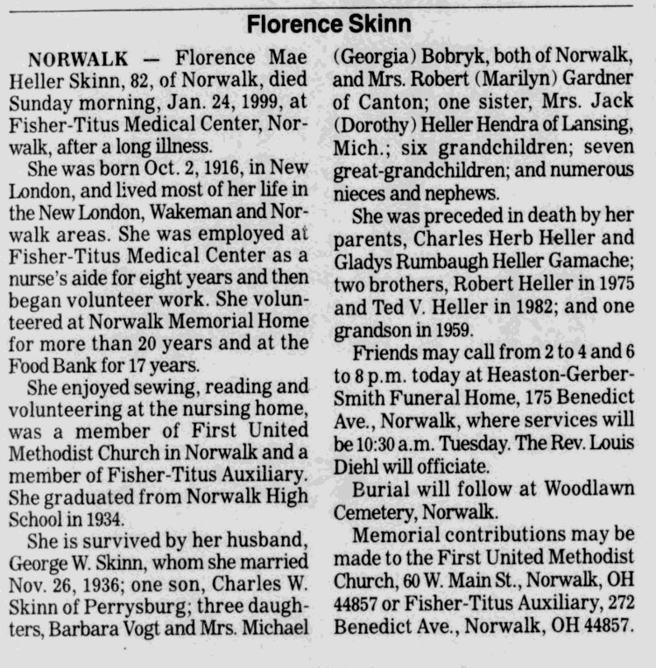

page 24 of: Sandusky Register January 25, 1999

